**Hyperparameter Tuning for Renewal + LexisNexis**

| **Params** | **A_Tr** | **P_Tr** | **R_Tr** | **f1_Tr** | **A_Val** | **P_Val** | **R_Val** | **f1_Val** | **Min_Max** |
| --- | --- | --- | --- | --- | --- | --- | --- | --- | --- |
| L1 - 0.1  L2 - 10  lr - 0.3 | 0.75 | 0.51 | 0.99 | 0.67 | 0.55 | 0.32 | 0.68 | 0.44 | 2 - 97 |
| L1 - 0.5  L2 - 10  lr - 0.3 | 0.92 | 0.88 | 0.79 | 0.84 | 0.70 | 0.41 | 0.32 | 0.36 | 1 - 97 |
| L1 - 0.1  L2 - 1  lr - 0.3  (best decile) | 0.68 | 0.45 | 0.99 | 0.62 | 0.52 | 0.32 | 0.77 | 0.45 | 1 - 96 |
| L1 - 0.1  L2 - 1  lr - 0.3  (100 best score attributes) | 0.90 | 0.84 | 0.76 | 0.80 | 0.71 | 0.42 | 0.31 | 0.36 | 1 - 97 |
| L1 - 0.1  L2 - 1  lr - 0.3  (50 best score attributes)  (best decile) | 0.87 | 0.80 | 0.69 | 0.74 | 0.69 | 0.37 | 0.32 | 0.35 | 1 - 93 |
| L1 - 0.1  L2 - 1  lr - 0.3  (35 best score attributes) | 0.62 | 0.40 | 0.98 | 0.57 | 0.48 | 0.30 | 0.78 | 0.43 | 7 - 96 |
| L1 - 0.1  L2 - 1  lr - 0.3  (Correlated features dropped)  (good decile) | 0.77 | 0.57 | 0.43 | 0.49 | 0.71 | 0.41 | 0.28 | 0.33 | 2 - 94 |
| L1 - 0  L2 - 1  lr - 0.3  (Correlated features dropped)  (Best decile) | 0.84 | 0.75 | 0.60 | 0.67 | 0.72 | 0.43 | 0.28 | 0.34 | 3 - 93 |
| L1 - 0  L2 - 2  lr - 0.3  (Correlated features dropped) | 0.84 | 0.72 | 0.61 | 0.66 | 0.71 | 0.42 | 0.29 | 0.35 | 3 - 90 |
| L1 - 0  L2 - 5  lr - 0.3  (Correlated features dropped) | 0.88 | 0.80 | 0.70 | 0.75 | 0.71 | 0.42 | 0.28 | 0.34 | 1-95 |
| L1 - 0  L2 - 0.5  lr - 0.3  (Correlated features dropped) | 0.89 | 0.81 | 0.74 | 0.77 | 0.71 | 0.4 | 0.23 | 0.29 | 1-96 |
| L1 - 0.5  L2 - 1  lr - 0.3  (Correlated features dropped) | 0.87 | 0.80 | 0.68 | 0.73 | 0.73 | 0.48 | 0.33 | 0.39 | 1-93 |

**L1 - 0.1, L2 - 1 lr - 0.3 (Train) (All attributes)**

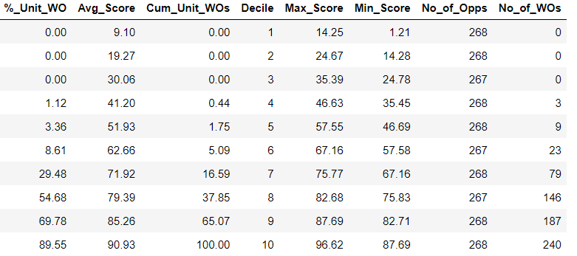

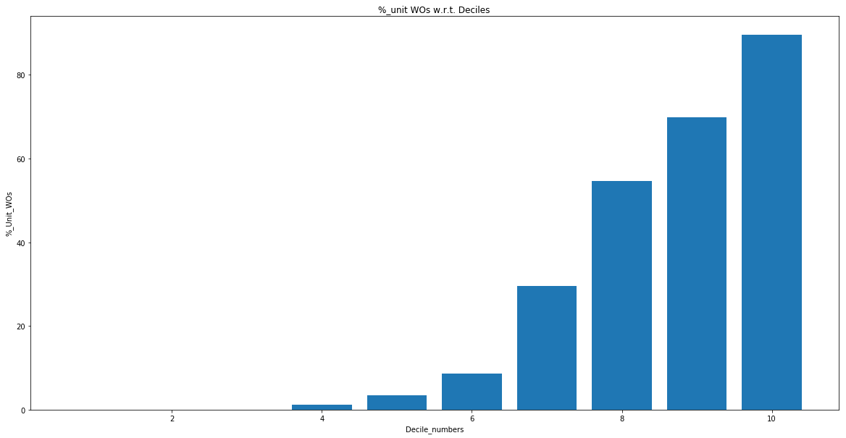

**L1 - 0.1, L2 - 1 lr - 0.3 (Val) (All attributes)**

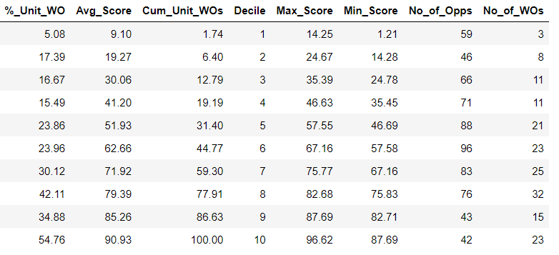

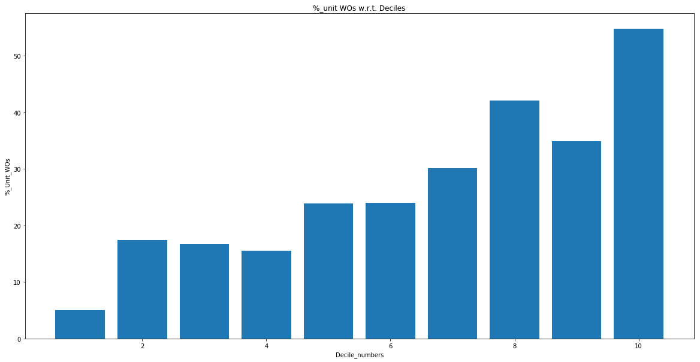

**L1 - 0.1, L2 - 1, lr - 0.3 (Train)(50 best features based on feature scores)**

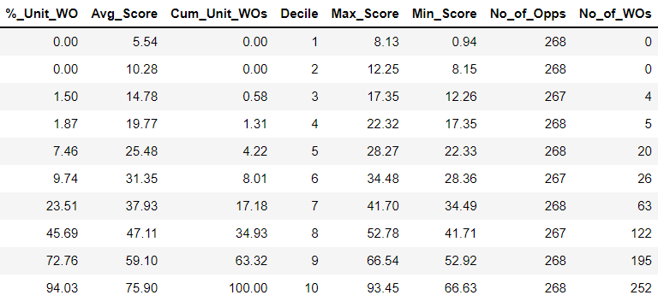

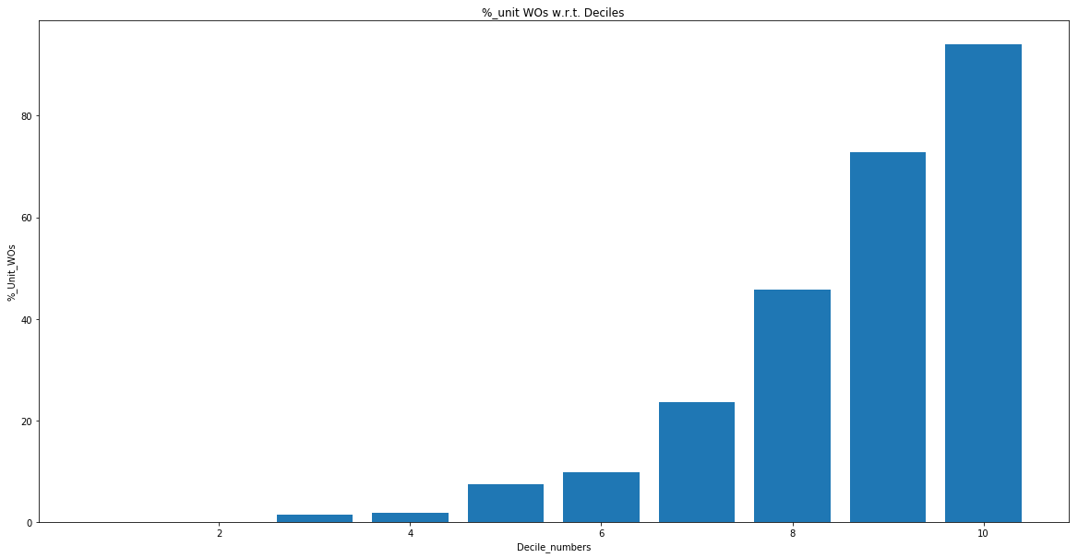

**L1 - 0.1, L2 - 1, lr - 0.3 (Val)(50 best features based on feature scores)**

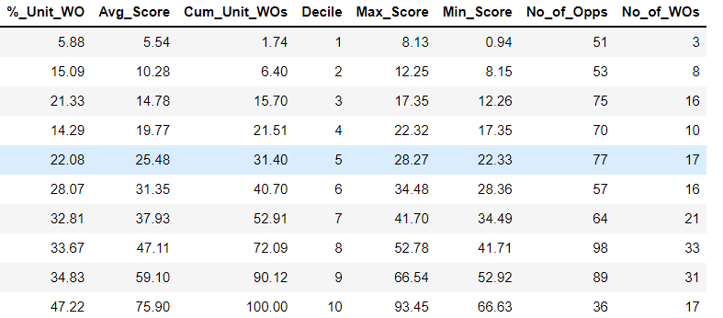

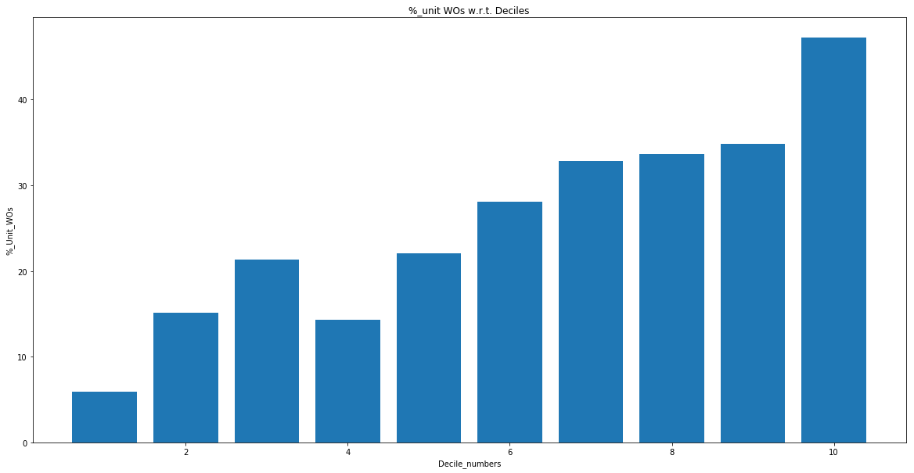

**L1 - 0, L2 - 1, lr - 0.3 (Train)(Correlated Features dropped )**

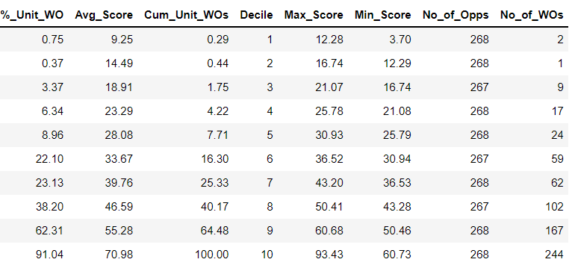

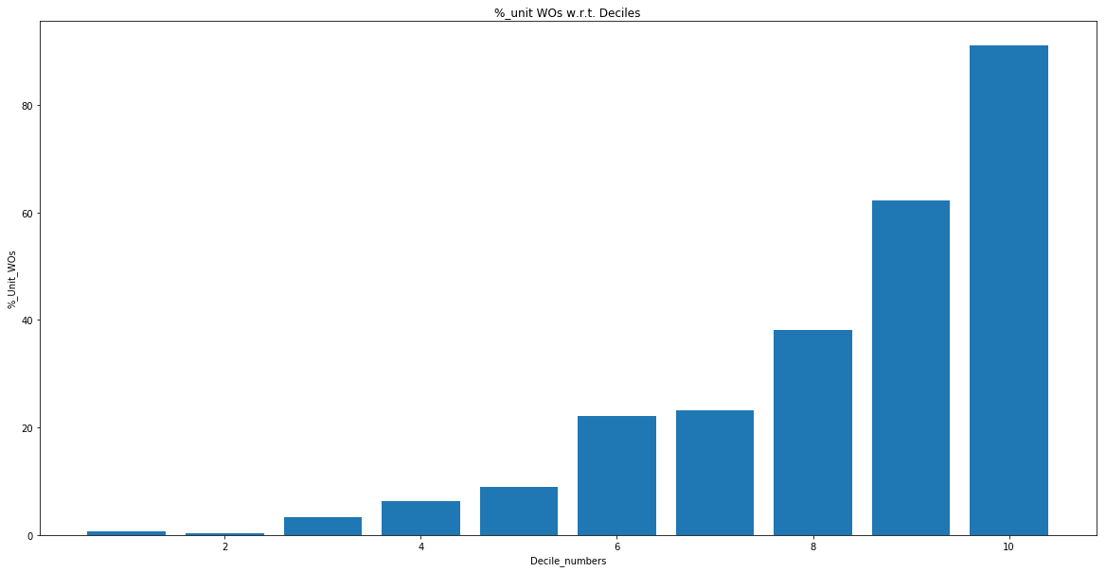

**L1 - 0, L2 - 1, lr - 0.3 (Val)(Correlated Features dropped )**

